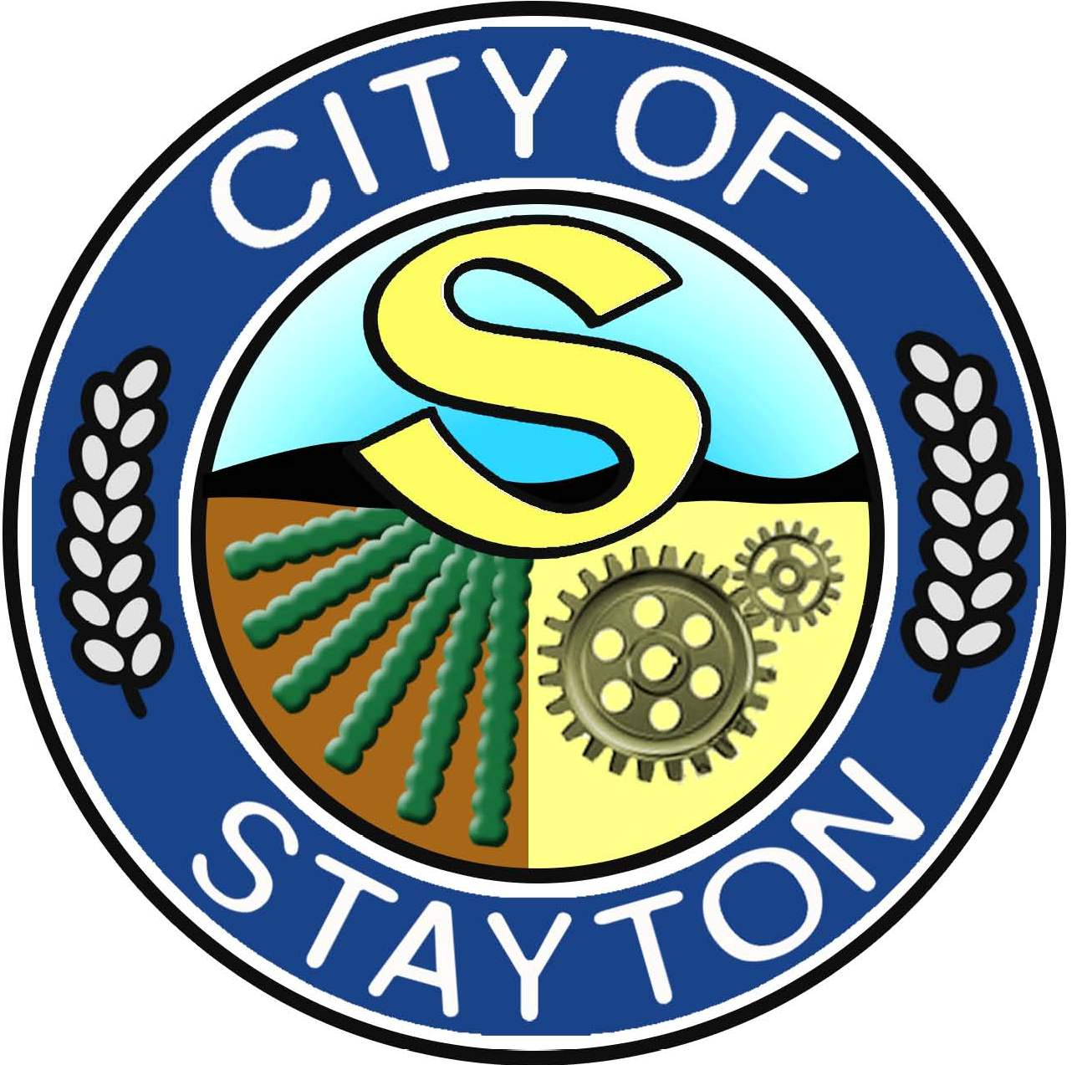
AGENDA
WORK SESSION
OF THE
STAYTON CITY COUNCIL
Monday, July 15, 2024
at 6:00 p.m.

E.G. Siegmund Meeting Room
Stayton Public Library
515 N. First Avenue
Stayton, Oregon 97383

HYBRID MEETING

The Stayton City Council will be holding a work session. If you would like to join the meeting virtually, please contact citygovernment@staytonoregon.gov no less than three hours prior to the meeting start time to make arrangements to participate.

Work Sessions are open to the public but do not allow for public comment.

CALL TO ORDER 6:00 P.M.

- Park Shelter Rentals/Facility Use Reservation Rules.

ADJOURN

